**PROBLEM SET 5**

Exercise 1 . SIR Model of Virus Spread

The number of Germany was provided in this Simulink model

N = 1 000 000

I = 2 274

R= 171 899

S= 1 000 000-171 899 – 2 274= 825 827

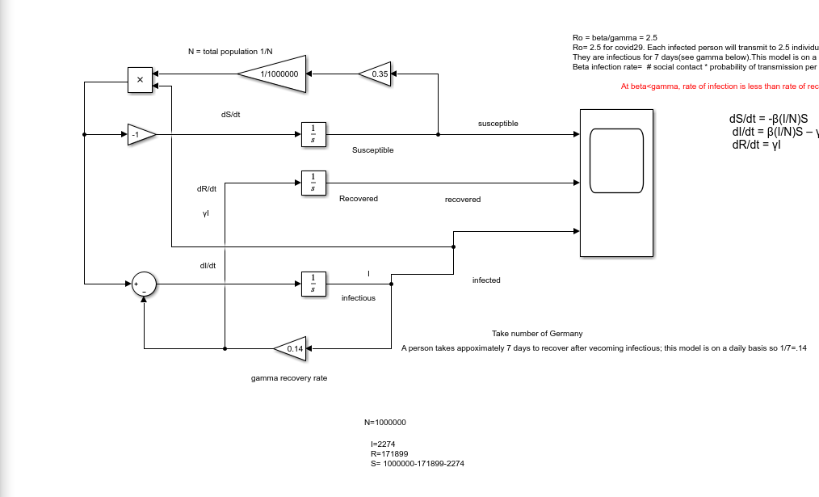

The result of the scope

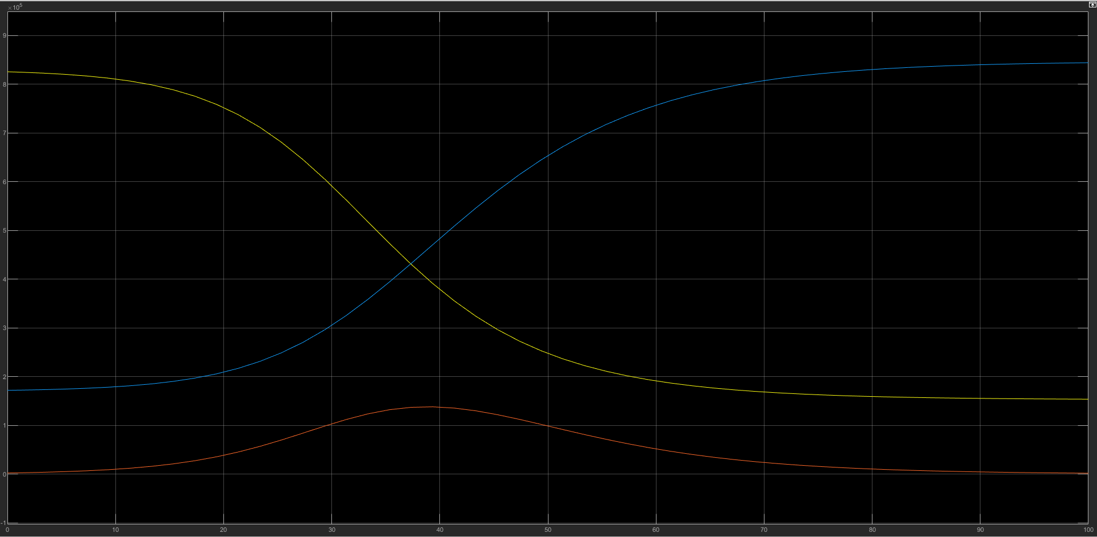

With R = 0.17, I =0.023 and S=0.825, Susceptible is falling while Recover Rate is rising and the Infected goes up to a peak then diminish.

Exercise 2: Poisson’s Equation

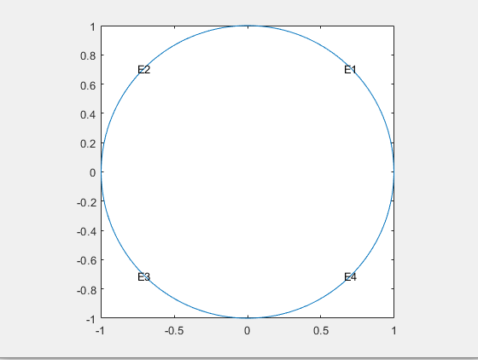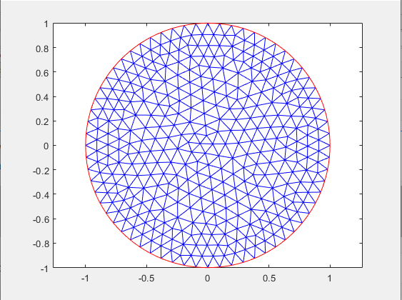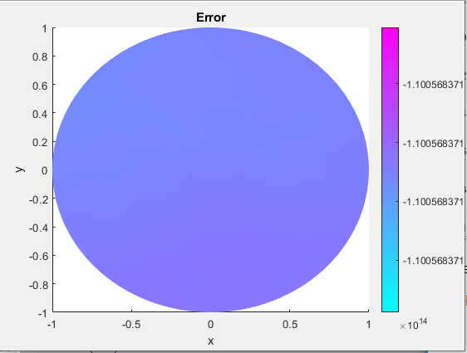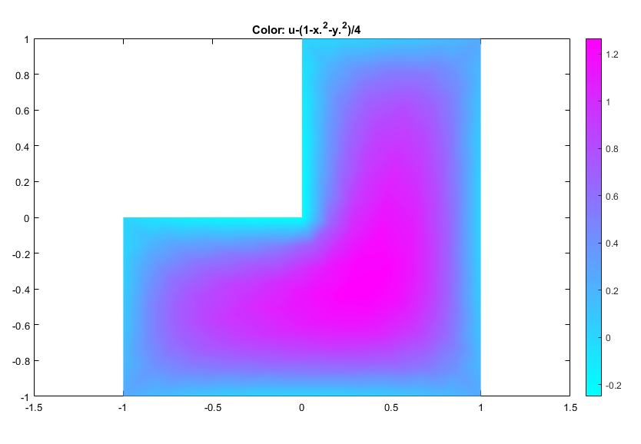

Exercise 3:

Helmholtz’s Equation:

$$∇^{2}f= -k^{2}f$$

So we have in this exercise:

$$-∆r+ k^{2}r=0$$

($∆=∇^{2}$)

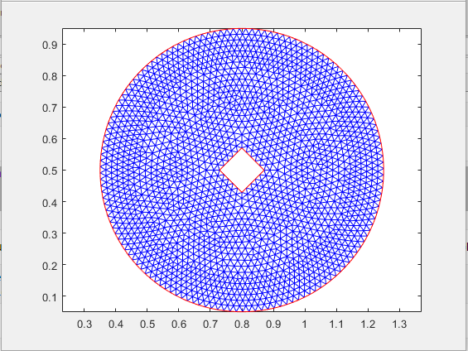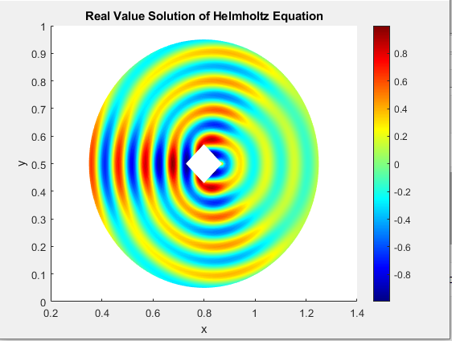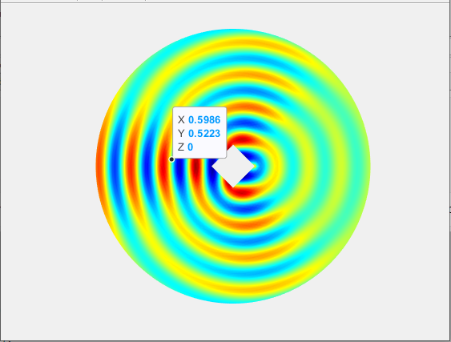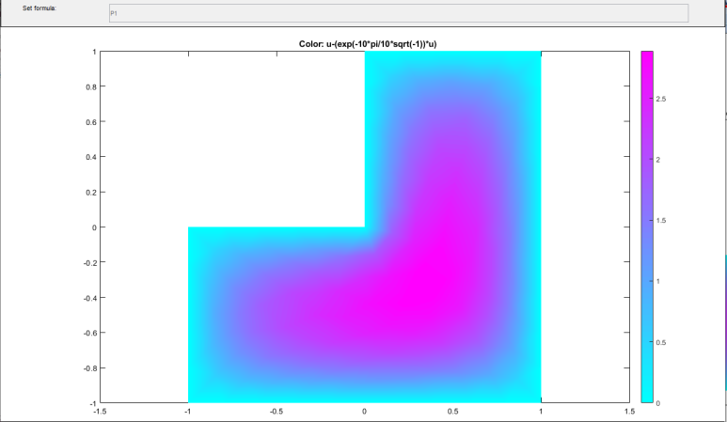

Exercise 4: Heat Equation

Heat Equation:

$$\frac{∂u}{∂t}-∆u=1$$

Initial Conditions: The temperature =1 and the surrounding =0

Boundary condition: Zero temperature on boundary.

Heat Equation is on cylindrical coordinates with r = 1.

$$\frac{∂u}{∂t}= \frac{1}{x}\frac{∂}{∂x}\left(x\frac{∂u}{∂x}\right)$$

Initial Conditions: $u\left(x,0\right)=J_{0}(nx)$

Boundary condition: $u\left(1,t\right)= J_{0}\left(n\right)e^{-n^{2}t}$

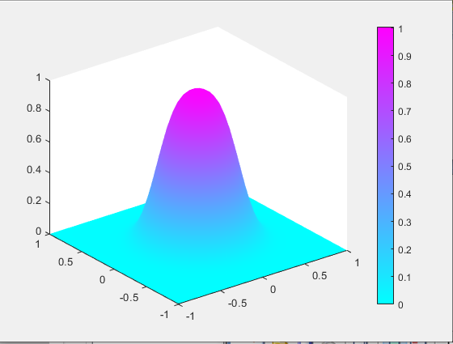

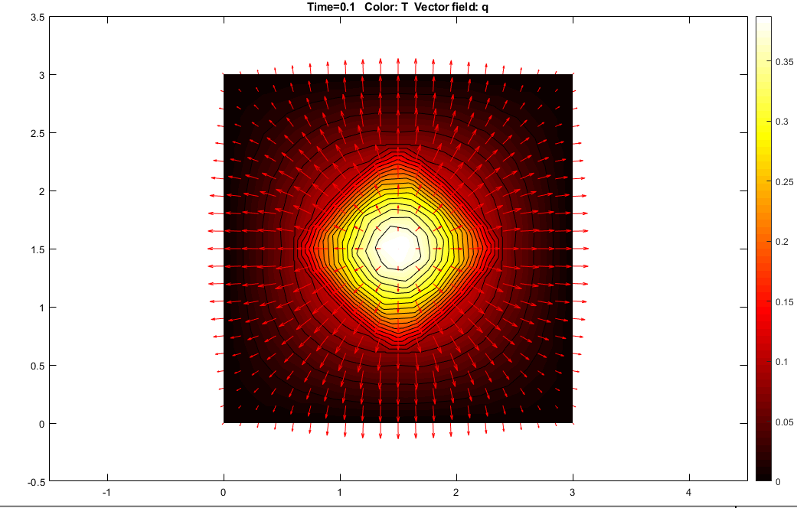

The heat equation is a partial differential equation that describes how the distribution of some quantity evolves over time in a solid medium, as it spontaneously flows from places where it is higher towards places where it is lower.

Exercise 5: Wave Equation

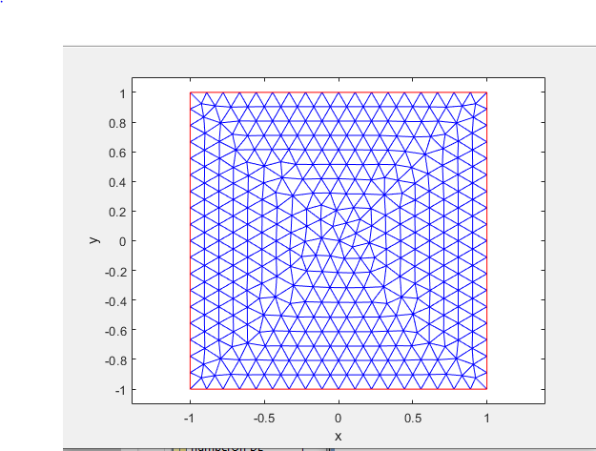

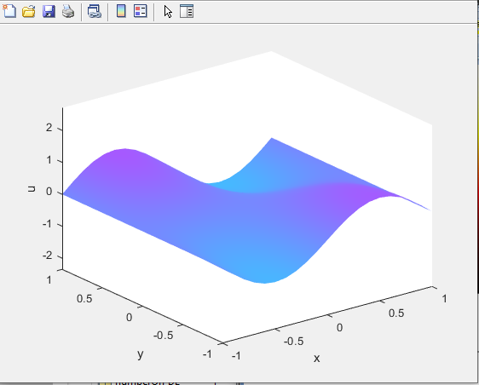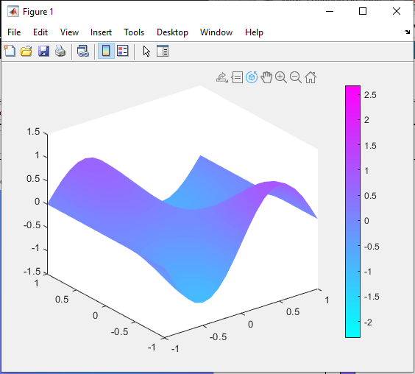

Set the following initial conditions:

$$u\left(0\right)=\operatorname{atan}\left(\cos\left(\frac{pi}{2}*x\right)\right)$$

$$u^{'}\left(0\right)= 3*\sin\left(pi*x\right).*exp⁡(sin⁡(\frac{pi}{2}*y))$$